**Demonstration of Carrier Wave/Upconversion**

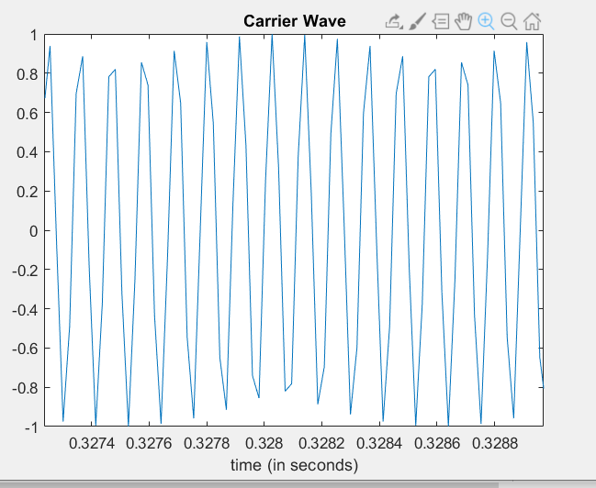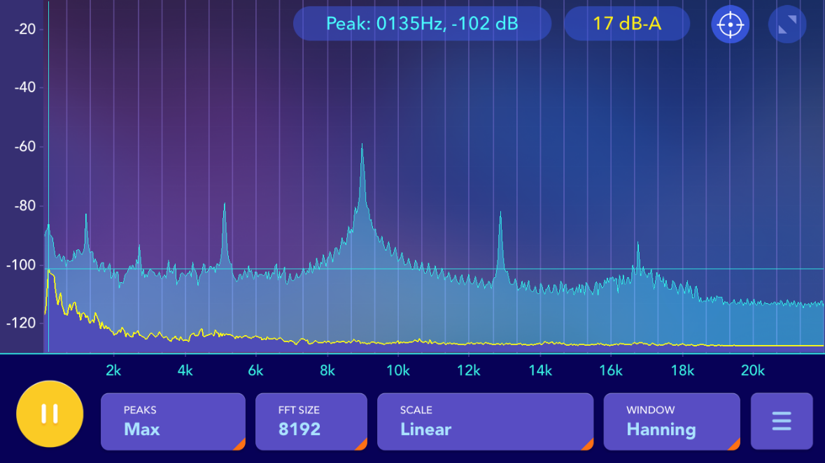

You can see the clear peak at 9kHz, our center frequency

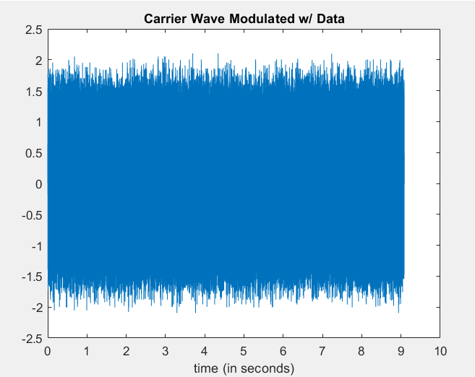

When 20000 data bits are modulated onto the carrier wave

